MgO-barrier magnetic tunnel junction goes flexible
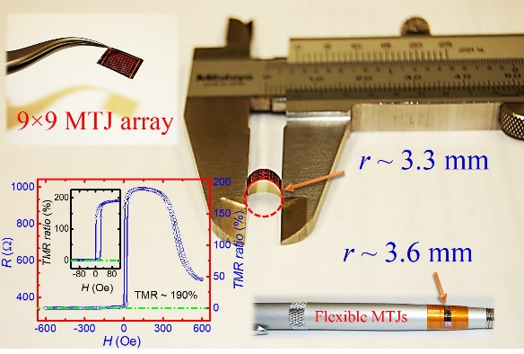
(2/2/2017) – A new article, which appeared online in Scientific Reports, from C-SPIN’s PIs Jian-Ping Wang (UMN) and Mo Li (UMN), has reported a method to fabricate high-performance MgO-barrier magnetic tunnel junctions directly onto ultrathin flexible silicon membrane.
The magnetic tunnel junction (MTJ) using MgO barrier is one of most important building blocks for spintronic devices for memory and computing applications and has been widely utilized as miniaturized magnetic sensors too. It could play an important role in wearable devices for internet of thing (IoT) applications if the junction could be fabricated on flexible substrates. The required stringent fabrication process to obtain high quality MgO-barrier MTJs, however, limit integration with flexible electronic devices. The demonstrated flexible MgO-barrier MTJs in this work open the door to integrating high-performance spintronic devices in flexible and wearable electronic devices for a plethora of sensing and computing in sensors applications.

